**3 CHAPTER THREE DESIGN**

## 3.1 Architecture and Deployment environment design

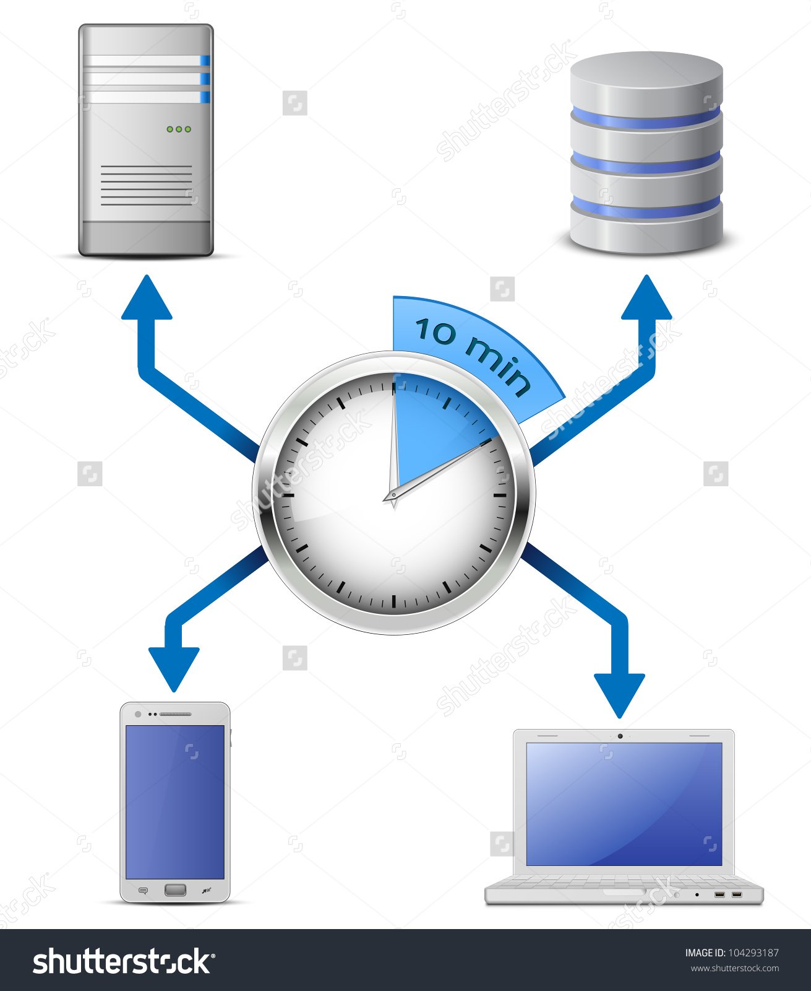

Figure (16) data distribution to and from database.

As an open platform, Android offers choice. You can distribute your Android apps to users in any way you want, using any distribution approach or combination of approaches that meets your needs. From publishing in an app marketplace to serving your apps from a web site or emailing them directly users, you’re never locked into any particular distribution platform.

The sections below highlight some of the alternatives for distributing your apps :

1. Distributing Through an App Marketplace

Google Play is the premier marketplace for Android apps and is particularly useful if you want to distribute your apps to a large global audience. However, you can distribute your apps through any app marketplace you want or use multiple marketplaces.

Unlike other forms of distribution, Google Play allows you to use the In-app Billing service and licensing service. The In-app Billing service makes it easy to sell in-app products like game jewels or app feature upgrades. The Licensing service helps prevent unauthorized installation and use of your apps.

1. Distributing through a website

If you don’t want to release your apps on a marketplace such as Google Play, you can make them available for download on your own website or server, including on a private or enterprise server. To do this, you first prepare your apps for release in the normal way. Then all you need to do is host the release-ready APK file on your website and provide a download link to users.

When users browse to the download link from their Android-powered devices, the file is downloaded and Android system automatically starts installing it on the device.

1. Releasing your application through email

The easiest and quickest way to release your application is to send it to a user through email. To do this, you prepare your application for release and then attach it to an email and send it to a user. When the user opens your email message on their Android-powered device the Android system will recognize the APK and display an **Install Now** button in the email message Users can install your application by touching the button.

**3.2 Design Class model**



Figure (17) class design model.

**3.3 Database design**

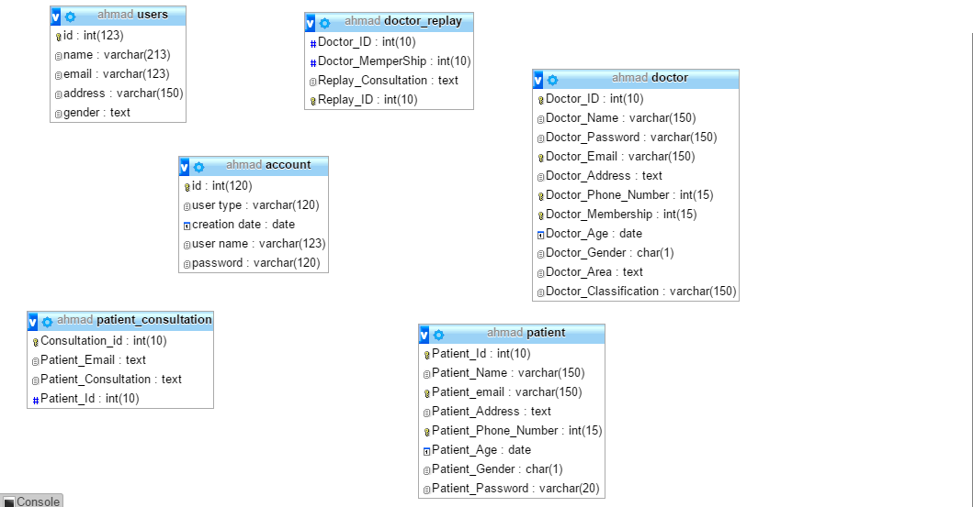

Figure (18) Er diagram.

**3.4 Design the system and user interface**

**3.4.1 The systems main screen**

As shown in figure (19) the systems main screen welcomes the user and displays a number of options like searching the application view other answered consultation and joining the application.

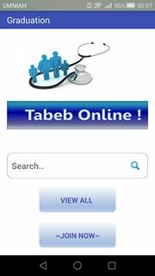

Figure (19) main screen.

**3.4.2 Choose user type screen**

As shown in figure (20) the user type screen provide the user with options such as logging in to the application or register as a patient or a doctor.

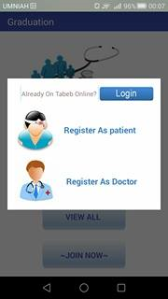

Figure (20) user type screen.

**3.4.3 Users login screen**

As shown in figure (21) the user should enter a valid username and password to login to the system once the entered data has matched an existing data in the database the user will be logged in to the system.

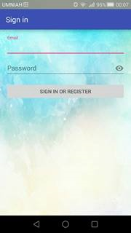

Figure (21) user login screen.

**3.4.4 Patient registration screen**

As shown in figure (22) the patient should enter information about himself such as name date of birth to register in the system.

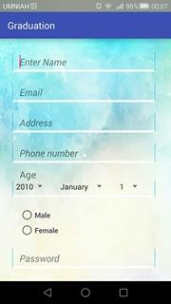

Figure (22) patient registration.

**3.4.5 Doctor registration screen**

As shown in figure (23) the doctor should enter information about himself such as name specialty and membership number in order to register to the system.

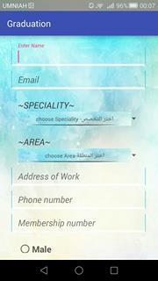

Figure (23) doctor registration.

**3.4.6 Patient screen**

As shown in figure (24) the patient writes his consultation in the specified field as well as choosing the doctors specialty and area.

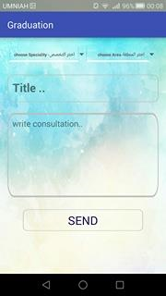

Figure (24) patient screen.

**3.4.7 Doctor screen**

As shown in figure(25) the doctor gets a notification which indicates that there is a consultation needs to be answered within his specialty he also can get a message to answer the consultation privately and check the most recent consultations as well.

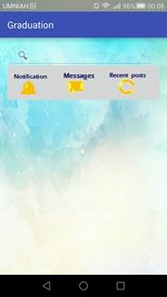

Figure (25) doctor screen.